[Title] must not exceed 14 words – Garamond 16 Alignment [left] outline level 1
[Author Name^{1]}, [Author Name²
Author names should be Garamond 11,Indention before 0.5 cm, spacing before 2.05 line with line spacing 1.5, Orcid numbers should be provided separately
¹Dept of xxx, University , state, country. Email.
²Dept of xxx, University , state, country. Email.
Author affiliation should be Garamond 7, alignment left, indention before 0.5 cm, spacing before auto, line spacing 1.5 lines

Abstract Alignment left, spacing before 12pt, after 4.8 pt, line spacing single.
Abstract content Garamond 10 alignment justified, outline level, body text spacing before 6ptm after 6pt, line spacing multiple at 1.07 In this content you are expected to indicate the purpose of the research, brief methodology, results, and if spacing allows implications the length should not exceed 250 words.
Keywords: Garamond 10, include 5-10 keywords.

Corresponding author: Name,Email

1. Introduction [Title, Garamond Bold, 11 alignment left, spacing before 20.4 pt, after 4.8 pt, line spacing single. ]
Alignment justified, outline level body text, before 6pt after 6 pt line spacing multiple 1.07. Garamond 10.
.

2. Literature Review [Title, Garamond Bold, 11 alignment left, spacing before 20.4 pt, after 4.8 pt, line spacing single. ]
Alignment justified,outline level body text, before 6pt after 6 pt line spacing multiple 1.07. Garamond 10.

2.1 Subtitle [Garamond 10, Bold, Italic, spacing before 17.1 pt, after 4.4 pt, line spacing single]
Alignment justified,outline level body text, before 6pt after 6 pt line spacing multiple 1.07. Garamond 10.

2.2 Subtitle [Garamond 10, Bold, Italic, spacing before 17.1 pt, after 4.4 pt, line spacing single]
Alignment justified,outline level body text, before 6pt after 6 pt line spacing multiple 1.07. Garamond 10.

3. Methodology[Title, Garamond Bold, 11 alignment left, spacing before 20.4 pt, after 4.8 pt, line spacing single. ]

3.1 Research Design[Garamond 10, Bold, Italic, spacing before 17.1 pt, after 4.4 pt, line spacing single]
Alignment justified,outline level body text, before 6pt after 6 pt line spacing multiple 1.07. Garamond 10.

4. Results[Title, Garamond Bold, 11 alignment left, spacing before 20.4 pt, after 4.8 pt, line spacing single. ]
Alignment justified,outline level body text, before 6pt after 6 pt line spacing multiple 1.07. Garamond 10.

TABLE 1. Describe the table briefly no more than 12 words [Alignment Left, Outline Level, Body Text]
Title 1, Garamond bold 10 | Title 2, Garamond bold 10 | Title 3, Garamond bold 10 | Title 4, Garamond bold 10
Garamond 10 | Garamond 10 | Garamond 10 | Garamond 10
Add as needed
Source:[ if author created the table no need to mention].

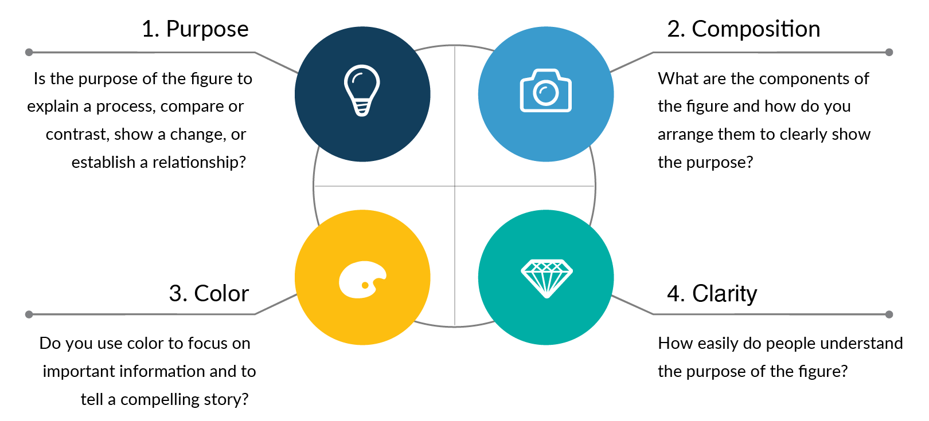
FIGURE 1. Figure 1 (Figure Caption)

5. Discussion[Title, Garamond Bold, 11 alignment left, spacing before 20.4 pt, after 4.8 pt, line spacing single. ]
Alignment justified,outline level body text, before 6pt after 6 pt line spacing multiple 1.07. Garamond 10.

6. Conclusion and Implications[Title, Garamond Bold, 11 alignment left, spacing before 20.4 pt, after 4.8 pt, line spacing single. ]
Alignment justified,outline level body text, before 6pt after 6 pt line spacing multiple 1.07. Garamond 10.

7. Limitations and Future Research[Title, Garamond Bold, 11 alignment left, spacing before 20.4 pt, after 4.8 pt, line spacing single. ]
Alignment justified,outline level body text, before 6pt after 6 pt line spacing multiple 1.07. Garamond 10.
regulators could further explain how AI is implemented, trusted, governed, and used in real financial reporting environments.

Declarations
Conflict of Interest
Example: The authors declare that they have no competing interests.
Funding
Example: No external funding was received for this study. The article processing charge/publication fee for this paper was waived by the publisher.
Ethics Approval
Example: This study was conducted in accordance with the ethical principles of the Declaration of Helsinki. The study involved voluntary survey participation by adult respondents. According to the applicable institutional requirements, formal ethical approval was not required for this type of non-interventional questionnaire-based research.
Consent to Participate
Example: Informed consent was obtained from all participants prior to their participation in the study.
Consent for Publication
Example: Not applicable.
Data Availability
Example: The data that support the findings of this study are available from the corresponding author upon reasonable request.
Authors’ Contributions
Example: F contributed to the structure draft writing, while M contributed in the Analysis .
Clinical Trial Number
Example: Not applicable.
Use of Artificial Intelligence
Example: The authors declare that generative artificial intelligence (AI) tools were used only to assist with language editing and clarity of expression during the preparation of the manuscript. The authors reviewed and edited all AI-assisted outputs and take full responsibility for the content, interpretation, and conclusions of the manuscript. No AI tools were used to generate, manipulate, or analyze the research data or to produce the scientific results of the study.

References[Title, Garamond Bold, 11 alignment left, spacing before 20.4 pt, after 4.8 pt, line spacing single. ]

References should be APA 7th and intext citation should follow APA, the references should be numbered mentioning the full metadata of each research. Example
- Abdo-Salloum, A. M., & Al-Mousawi, H. Y. (2025). Accounting students' technology readiness, perceptions, and digital competence toward artificial intelligence adoption in accounting curricula. Journal of Accounting Education, 70, Article 100951. https://doi.org/10.1016/j.jaccedu.2025.100951

Annex I [Alignment left, outline level 1, spacing before 12 pt after 4.8 line spacing single.]

All Annexes related materials should be Garamond 10

